SOP for ZY_PinBridge

Application: EthoVision-controlled Arduino I/O for a single behavioral chamber.

One-Time Setup
- Flash the Arduino firmware
  - Open ZY_EthovisionIO.ino in Arduino IDE and flash it to Arduino Uno R3.
- Optional: Test the Arduino
  - Open the Arduino IDE Serial Monitor
  - Test the connection by manually sending: p=13,v=1,d=5
  - Confirm that the command works correctly with pin13-LED on Arduino Uno R3
  - Close the Serial Monitor after testing.
- Optional: Rebuild the exe files (only needed if you want to modify the .cs source code)
  - Run build_UI.bat to recompile the .exe files.
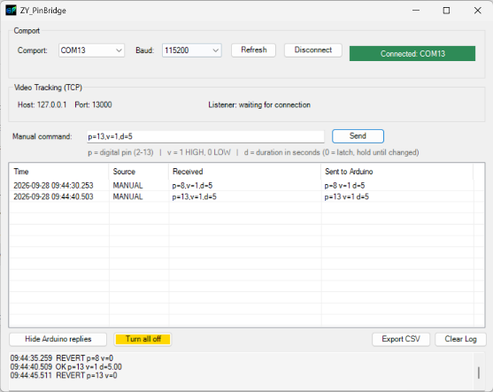
Experimental Procedure
- Connect the Arduino
  - Connect Arduino to the PC and identify its COM port in Device Manager.
- Start ZY_PinBridge_UI
  - Launch ZY_PinBridge_UI.exe.
  - Select the correct COM port and connect: it should shows “Connected”.
  - Leave ZY_PinBridge_UI running.
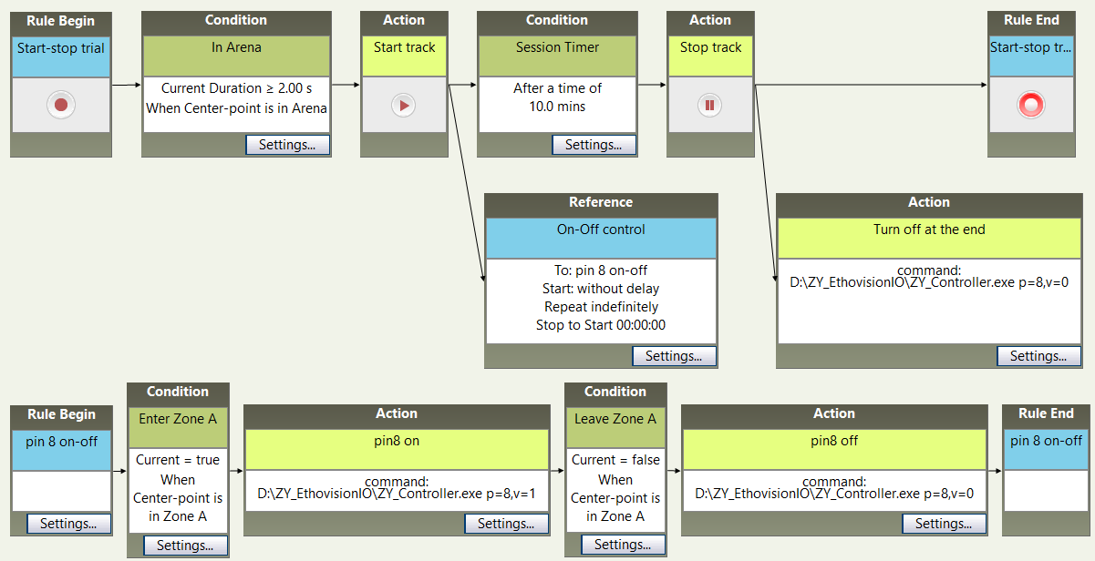
- Configure EthoVision
  - In EthoVision, create an External Command Action.
  - Set Select program to run to: ZY_PinBridge_Controller.exe
  - Enter the desired command under Command line options (accepted pins 2-13).
Examples:
    - p=8,v=1 → turn Pin 8 ON
    - p=8,v=1,d=30 → turn Pin 8 ON for 30 seconds
    - p=8,v=0 → turn Pin 8 OFF
- Run the Experiment
  - Start the experiment in EthoVision.
  - Keep ZY_PinBridge_UI running throughout the session.
  - Monitor the Adapter log to confirm that commands are being received and executed correctly.

